Experiment 3
Objective: Experimental verification of following electrical circuit problems using:
- Kirchhoff’s current law
- Kirchhoff’s voltage law
Apparatus required: Battery, multimeters, Resistors and potentiometers.
Theory:
Kirchhoff’s Current Law
- At any node (junction) in an electrical circuit, the sum of currents flowing into that node is equal to the sum of currents flowing out of that node.
- The algebraic sum of currents in a network of conductors meeting at a point is zero.
$$\sum_{k=1}^{n}{I_{k}=0}$$
N is total no. of branches with currents towards and away from the node.

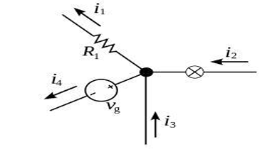
Kirchhoff’s voltage Law
Any closed loop in a circuit, the algebraic sum of the potential differences across all elements is zero.
$$\sum_{k=1}^{n}{V_{k}=0}$$
Circuit Diagram:
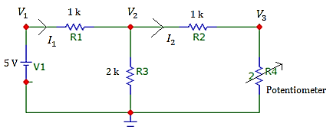
PROCEDURE:
- Connection made as per the circuit diagram.
- Switch the ON the supply
- The potential divider is gradually varied in steps and each step the reading of ammeters noted down.
- The readings are tabulated.
TABULATION (HARDWIRED)
Verification of Kirchoff's Current Law
S.N. | Resistance of Potentiometer (ohm) | $$V_{1}$$ | $$V_{2}$$ | $$V_{3}$$

Verification of Kirchoff's Voltage Law
S.N. | Resistance of Potentiometer (ohm) | $$I_{1}$$ | $$I_{2}$$

RESULT: Hence the Kirchoff’s laws were verified using both hardwired components and Microcap.
Learning Outcomes:

